NEAR MISS REPORTING
What is a Near Miss?
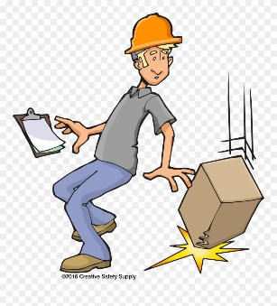
A Near Miss is any unplanned event that did not result in injury, illness, or damage – but had the potential to do so.
- Something you tripped on but did not fall
- A guard that was not in place
- Someone walking out in front of your moving vehicle, but you did not hit them.
- Something falling from a shelf but did not strike anyone but could have should they have been walking by.
Only a fortunate break in the chain of events prevented an injury, fatality or damage; in other words, a miss that was nonetheless very near. A faulty process or management system invariably is the root cause for the increased risk that leads to the near miss and should be the focus of improvement. Other familiar terms for these events are a “close call,” a “narrow escape,” or in the case of moving objects, “near collision” or a “near hit.”

To report a near miss, use the A-262 Employee Injury Reporting Form and check the “Near Miss” box at the top of the page. Complete it as you would if you had suffered an injury. In the event description, use as much detail as possible so what exactly happened is understood. It is not important that you enter your name but we encourage you to enter it as it will allow us to contact you should there be any questions and we can discuss any and all corrective actions need for future occurrences.
Forward the report to your immediate supervisor for review, crew discussion(s) and signature.
Please forward the report to the Employee Health and Safety Team as soon as possible!!
If you have any questions or concerns regarding this process, please contact the Employee Health and Safety Team.
